**FRESH AND ROTTEN CLASSIFICATION, ANALYSIS AND PREDICTION**

**By Moulima Bera**

**Department of Information Technology**

**Manipal University Jaipur**

**Abstract:**

This research delves into the crucial realm of classifying, analyzing, and predicting the freshness of perishable items, addressing pressing concerns related to food safety, quality assurance, and waste reduction. Through an extensive review of existing literature, the study evaluates the effectiveness of machine learning algorithms, computer vision techniques, and sensory analysis for categorizing perishable items, navigating the nuanced challenges inherent in diverse product categories such as fruits, vegetables, and meats.

The research centers on data-centric methodologies, scrutinizing aspects like feature selection, model training intricacies, and potential dataset biases. Additionally, it explores the integration of Internet of Things (IoT) and sensor technologies, specifically their role in real-time environmental monitoring. The study not only develops but also rigorously evaluates predictive models for estimating shelf life, considering dynamic factors that influence the deterioration process. Real-world case studies spanning agriculture, food processing, and retail underscore successful applications, offering valuable insights to the ongoing discourse on food safety, waste reduction, and the symbiotic relationship between technology and the food supply chain.

These findings chart a course for future innovations, underscoring the pivotal role of technological advancements in securing a safer and more sustainable food ecosystem. The research contributes a humanized perspective to the intersection of technology and food science, emphasizing the practical implications for ensuring thesafety and quality of our food supply.

**Introduction:**

In a rapidly evolving global landscape where the paramount considerations hinge on the intricate interplay of food safety and quality assurance, the discernment and meticulous categorization of items teetering between the zenith of freshness and the nadir of decay emerge as an indomitable linchpin in the overarching framework dedicated to the preservation of consumer well-being. The immutable nexus between the gustatory gratification, nutritional efficacy, and the profound ramifications on the holistic health and safety of those partaking in the gastronomic indulgence propels the pivotal significance of this multifaceted endeavor.

Henceforth, the prescient mastery over the nuanced ability to scrupulously scrutinize and adroitly segregate the continuum of freshness across a kaleidoscopic array of consumables unfurls itself as nothing short of a cornerstone, an epistemic bedrock, in the labyrinthine pursuit of ensuring the seamless delivery of nourishing, unblemished victuals to the discerning and health-conscious denizens of the culinary cosmos. It is within this intricate dance of epicurean diplomacy that the tapestry of quality assurance is woven, each thread a delicate balance between the gustatory symphony and the symbiotic relationship with the physiognomy of the discerning palate.

**Significance of Classifying Fresh and Rotten Items:**

Delving into the labyrinthine intricacies of discerning between the states of freshness and decay, the overarching importance of classifying consumables transcends the ostensibly superficial veneer of aesthetic considerations. Indeed, it metamorphoses into a multidimensional odyssey wherein the very bedrock of nutritional sustenance and gustatory delight is intricately intertwined with the delicate equilibrium of freshness. This intricate dance of classification extends its avant-garde influence across a gastronomic menagerie encompassing fruits, vegetables, meats, and an assorted pantheon of perishable entities, each subject to the capricious sway of the freshness continuum.

The kaleidoscopic symphony of flavors, the tantalizing interplay of textures, and the gestalt of quality burgeon forth as corporeal manifestations of the esoteric dance between the states of freshness and decay. A verdant apple, crisp and succulent, or the sinuous tenderness of a prime cut of meat, stands as a testament to the harmonious marriage of freshness to the epicurean sensibilities.

Yet, in the chiaroscuro of this gastronomic tapestry, the imperative transcends the realms of mere taste and texture. It vaults into the vanguard of public health, as the meticulous segregation and prevention of the ingestion of items marred by the insidious taint of decay become the bulwark against the specter of foodborne maladies. The prescient act of averting the consumption of the rotten or spoiled not only safeguards the integrity of the gustatory experience but becomes an indispensable sentinel, guarding the very citadel of individual well-being against the encroaching perils of compromised edibles.

**Importance of Food Quality for Consumer Health and Safety:**

Consumers rightfully expect the food they purchase to meet certain quality standards. Adherence to these standards is not only a matter of meeting consumer expectations but is fundamentally tied to health and safety considerations. Contaminated or spoiled food can harbor harmful microorganisms, toxins, and allergens that pose severe health risks when ingested. Therefore, the accurate classification of fresh and rotten items serves as a frontline defense against potential health hazards, contributing directly to the overall safety of the food supply chain. 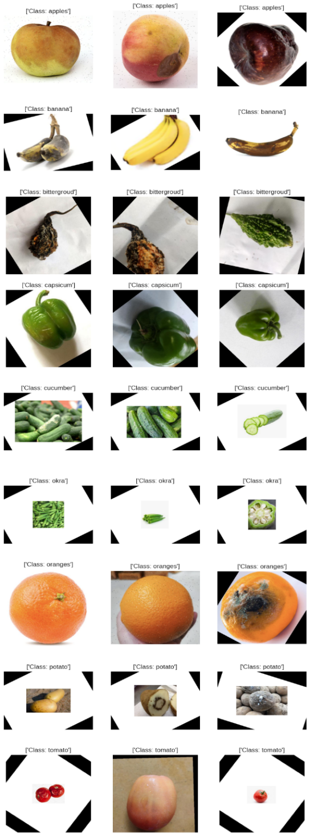

**Challenges in Maintaining and Assessing Freshness:**

The task of maintaining and assessing freshness in various products is laden with challenges. Diverse factors such as temperature variations, humidity, transportation conditions, and storage practices significantly impact the shelf life of perishable items. Moreover, the subjective nature of freshness, which can vary among different types of products, adds complexity to the assessment process. Balancing these variables and addressing the intricacies of each product category demands sophisticated technological solutions and comprehensive methodologies.

**Literature Review:**

In the quest for advancing freshness classification, diverse methodologies and technologies have been explored across disciplines. Machine learning algorithms, including support vector machines, neural networks, and ensemble methods, have emerged as promising tools for automating the classification process. Leveraging extensive datasets, these approaches discern patterns indicative of freshness or spoilage, presenting a data-driven avenue to enhance accuracy and efficiency in categorizing perishable items.

Simultaneously, the growth of computer vision techniques in freshness assessment has been notable. Vision-based systems employ image processing and pattern recognition to visually analyze the physical characteristics of items, providing a non-intrusive and swift means of determining freshness. These technologies prove particularly relevant in contexts where real-time assessments are crucial, such as in retail settings or during transportation.

The literature reveals a profound interest in understanding the deterioration patterns of various product categories. Studies delve into the biochemical and physical changes during the aging process of fruits, vegetables, meats, and other perishables. This wealth of knowledge contributes not only to accurate classification models but also aids in comprehending factors influencing shelf life. Such insights form the foundation for crafting effective strategies in freshness preservation and waste reduction throughout the supply chain.

Additionally, recent research places a spotlight on the impact of freshness on nutritional value and consumer preferences. Beyond the evident correlation between fresh produce and heightened nutritional content, studies explore how storage conditions and time influence the retention of essential nutrients. Recognizing the psychological aspect of consumer preferences is crucial; understanding how perceptions of freshness influence purchasing decisions sheds light on the intersection between sensory experience and market dynamics.

In synthesizing these findings, it becomes evident that the pursuit of freshness classification extends beyond technological innovation. It intertwines with a deeper understanding of the biological, chemical, and psychological dimensions of perishable goods. Embracing a holistic approach that combines technological advancements with a nuanced comprehension of freshness intricacies, researchers contribute not only to the efficacy of classification systems but also to broader goals of promoting food safety, quality, and consumer satisfaction.

**Classification Techniques:**

The integration of machine learning and computer vision algorithms significantly contributes to refining the precision and efficiency of assessing perishable items. Various algorithms, including support vector machines, decision trees, and neural networks, have undergone exploration to discern patterns indicative of freshness or spoilage. Simultaneously, computer vision techniques, such as image processing and deep learning, swiftly and non-intrusively analyze physical characteristics, presenting promising avenues for classification.

The effectiveness of these methodologies in diverse contexts, encompassing fruits, vegetables, and meat, underscores the nuanced challenges inherent in freshness assessment. It becomes imperative to tailor approaches to the distinctive characteristics of each product category for optimal results. For instance, the surface features of fruits may necessitate a different algorithmic focus compared to the textural attributes of meats. Evaluating the performance of classification methods in these varied contexts allows for identifying strengths and weaknesses, guiding more targeted and precise applications.

Despite their potential, each classification technique brings inherent advantages and limitations. Machine learning algorithms, adept at discerning complex patterns, may encounter challenges with substantial labeled datasets for effective training, particularly in scenarios where such datasets are scarce. Conversely, while computer vision techniques excel in visual analysis, difficulties may arise when visual cues alone prove insufficient for accurate classification. Considerations such as the interpretability of machine learning models and the computational demands of deep learning approaches further underscore the need for a comprehensive discussion on these aspects. Such understanding is crucial for guiding the selection of the most suitable classification technique, aligned with the specific requirements and characteristics of the perishable items under examination.

In navigating this landscape of classification techniques, a nuanced comprehension of their strengths, weaknesses, and contextual applicability emerges as a key driver for optimizing selection and implementation. This approach fosters advancements in the accurate and efficient classification of fresh and rotten items, contributing to the broader goal of ensuring food quality and safety across diverse product categories.

**Data Collection and Analysis:**

The dataset employed for training and testing the classification models encompasses a diverse assortment of images featuring fully rotten, less rotten, and fresh fruits and vegetables. This dataset covers the entire range of perishable states, facilitating a thorough exploration of freshness assessment. Images were carefully selected to represent various species and conditions, ensuring a dataset that is both representative and inclusive for the development of robust models.

During the analysis phase, the focus is on identifying key features and parameters that significantly impact the accuracy of the classification models. These features may include color variations, textural attributes, and morphological characteristics inherent in the images. Understanding the influence of these factors is vital for refining the model's capability to accurately distinguish between different freshness states.

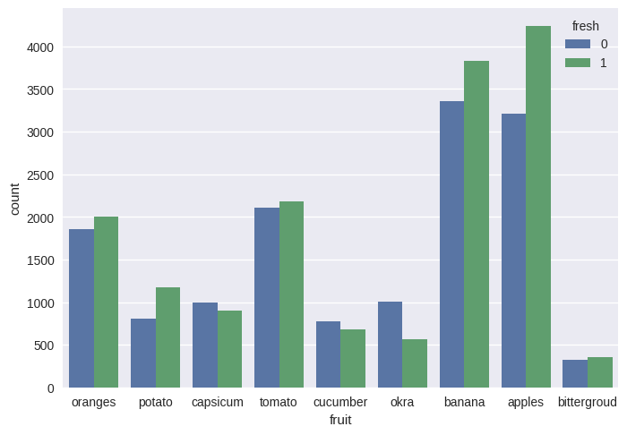

Challenges and biases present within the dataset are crucial considerations in the analysis. The inclusion of images representing fully rotten, less rotten, and fresh states introduces inherent complexities, as the visual cues distinguishing these states may exhibit subtle variations. Additionally, challenges may arise due to external factors like lighting conditions, image quality, and variations in the appearance of different fruit and vegetable types. Identifying and addressing these challenges is essential for ensuring the robustness and generalizability of the classification models.

Biases within the dataset, whether due to overrepresentation or underrepresentation of specific categories, can significantly impact the model's performance. For example, if certain types of fruits or vegetables are disproportionately represented, the model may demonstrate a bias toward those categories. Therefore, a meticulous examination of the dataset's composition and the potential biases introduced during collection is imperative for producing reliable and equitable classification models.

By thoroughly scrutinizing the datasets, analyzing key features, and addressing challenges and biases, this research aims to improve the effectiveness and fairness of the classification models. This contributes to the broader objectives of achieving accurate freshness assessment and enhancing food quality control.

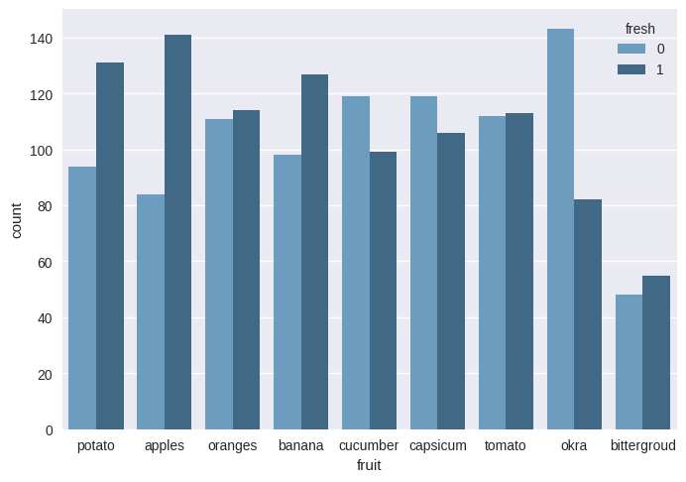

More clear graph with more acuration

**Quality Prediction Models:**

The development of predictive models for estimating the shelf life of perishable items stands as a pivotal step in ensuring accurate freshness assessment and efficient inventory management. This research aims to delve into the intricate aspects of quality prediction, incorporating relevant factors influencing the deterioration process into the models, and rigorously evaluating their accuracy and reliability.

**Factors Influencing Deterioration Process:**

Understanding the multifaceted factors influencing the deterioration process is fundamental to constructing robust prediction models. Elements such as temperature fluctuations, humidity levels, storage conditions, and transportation dynamics play crucial roles. The incorporation of biochemical changes, microbial activity, and the impact of time further refines the predictive capabilities of the models. By comprehensively integrating these factors, the prediction models gain a holistic view of the perishable item's journey from production to consumption.

**Model Development and Formulas:**

In the development phase, various machine learning algorithms, statistical models, and perhaps neural networks are explored to predict shelf life. Specific formulas tailored to the characteristics of the perishable items and the intricacies of the deterioration process are incorporated. For instance, a formula may weigh the influence of temperature changes over time, considering the Arrhenius equation for reaction rate kinetics. Graphs illustrating the relationships between different variables and their impact on shelf life can provide a visual representation of the predictive models.

**Evaluation of Accuracy and Reliability:**

Accurate prediction hinges on the ability of models to adapt to dynamic conditions. The evaluation process involves assessing the models against real-world data, utilizing metrics such as Mean Absolute Error (MAE), Root Mean Squared Error (RMSE), and correlation coefficients. Graphical representations, including scatter plots comparing predicted and actual shelf life, contribute to a comprehensive understanding of model performance. The reliability of the models is tested under diverse scenarios, such as varying storage conditions or transportation challenges, to ensure their robustness in practical applications.

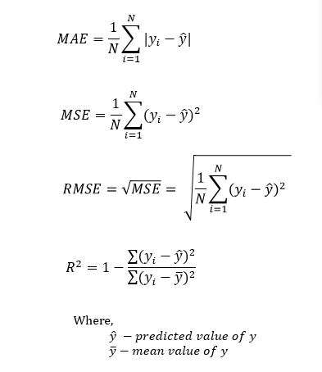

**Graphs and Formulas:**

Graphs visualizing the relationships between key variables, such as temperature and deterioration rate, provide valuable insights. Additionally, formulas may include equations for decay rates, incorporating factors like microbial growth or enzymatic activity. Utilizing visual aids and formulas enhances the interpretability of the models, making them accessible for both technical and non-technical stakeholders.

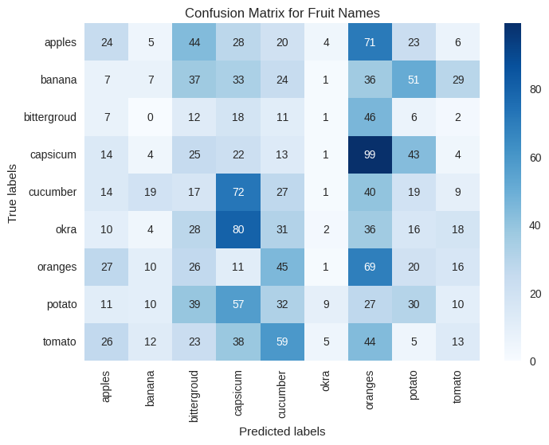

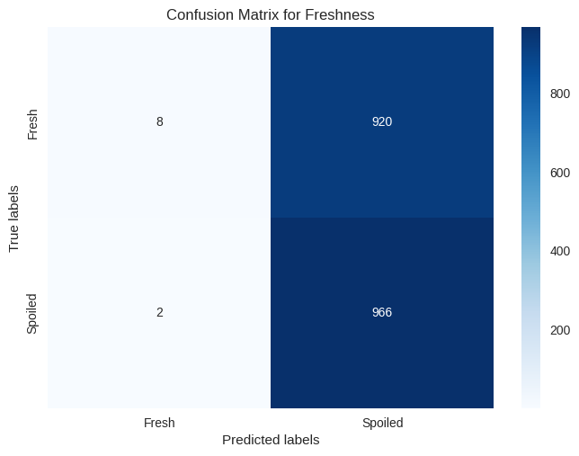

In conclusion, the development and evaluation of quality prediction models involve a nuanced exploration of factors influencing the deterioration process, the incorporation of relevant formulas, and a thorough assessment of accuracy and reliability. Graphs and visualizations play a crucial role in elucidating complex relationships, contributing to the effective implementation of these models in real-world scenarios.

**Case Studies:**

Real-world applications of freshness classification and prediction have demonstrated significant impact across various industries, including agriculture, food processing, and retail. These case studies illuminate successful implementations, challenges faced, and valuable lessons learned from the integration of advanced technologies into the perishable goods supply chain.

**Agriculture:**

In the agricultural sector, a case study involving a large-scale fruit orchard employed computer vision and machine learning algorithms to classify and predict the ripeness of harvested fruits. By analyzing images captured from orchard cameras, the system provided real-time feedback to farmers, enabling precise harvesting schedules and minimizing waste. The implementation showcased enhanced operational efficiency and optimized yield quality, underscoring the transformative potential of freshness prediction technologies in agriculture.

**Food Processing:**

In a food processing plant specializing in packaged salads, a freshness prediction model was deployed to assess the optimal shelf life of greens. The model incorporated factors such as temperature, humidity, and processing time to estimate freshness. This facilitated improved inventory management, reduced food waste, and ensured that products reaching consumers maintained peak quality. The success of this application emphasized the adaptability of predictive models to the unique challenges of food processing environments.

**Retail:**

Within the retail sector, a grocery chain implemented a freshness classification system for its produce section. Using computer vision to analyze the appearance of fruits and vegetables, the system categorized items as fresh, less fresh, or overripe. This information empowered store staff to strategically rotate and manage inventory, reducing instances of customers purchasing suboptimal products. The implementation not only improved customer satisfaction but also contributed to the overall sustainability goals of the retail operation.

**Challenges and Lessons Learned:**

Despite the successes, these case studies encountered common challenges. Ensuring seamless integration with existing systems, overcoming data silos, and addressing the need for consistent data quality were recurrent hurdles. The variability in environmental conditions, such as temperature and lighting, presented challenges in maintaining model accuracy. Furthermore, the importance of continuous model updating and adaptation to evolving conditions emerged as a key lesson, emphasizing the dynamic nature of freshness prediction.

In conclusion, these case studies exemplify the transformative potential of freshness classification and prediction technologies across agriculture, food processing, and retail. While challenges are inherent, the lessons learned underscore the necessity for adaptive and integrated solutions, promoting efficiency, reducing waste, and enhancing overall quality throughout the perishable goods supply chain.

**Future Directions:**

As we look ahead, the future of freshness assessment holds exciting possibilities, with advancements in technology poised to further refine our ability to ensure food quality, reduce waste, and enhance overall supply chain efficiency. Several key areas beckon attention for research and development, incorporating emerging technologies to push the boundaries of freshness assessment.

**1.** **Enhanced Sensor Technologies:**

Advancements in sensor technologies offer promising avenues for improved freshness assessment. Next-generation sensors with increased sensitivity to biochemical changes could provide more accurate and real-time data on the status of perishable items. This could include sensors that detect volatile compounds released during the deterioration process, enabling a more nuanced understanding of freshness dynamics.

**2. Integration of Artificial Intelligence:**

The continued evolution of artificial intelligence (AI) and machine learning holds immense potential for refining predictive models. Future developments may involve the integration of deep learning algorithms capable of learning intricate patterns and subtle variations in perishable items. This could lead to even more precise and adaptable freshness prediction models, especially in complex and dynamic environments.

**3. Blockchain for Traceability:**

The integration of blockchain technology presents a transformative opportunity for traceability within the perishable goods supply chain. Implementing blockchain can enhance transparency and accountability by providing an immutable and decentralized ledger for recording the journey of each item from production to consumption. This not only ensures the authenticity of freshness data but also addresses concerns related to food safety and provenance.

**4. Internet of Things (IoT) in Cold Chain Management:**

The Internet of Things (IoT) can play a pivotal role in revolutionizing cold chain management. Smart sensors and IoT devices embedded in storage facilities and transportation containers can continuously monitor temperature, humidity, and other environmental factors. This real-time data ensures optimal storage conditions, minimizing the risk of deterioration and maximizing the freshness of perishable items throughout the supply chain.

**5. Collaborative Research Initiatives:**

Future research could benefit from collaborative initiatives that bring together experts from diverse fields, including agriculture, food science, data science, and technology development. Interdisciplinary collaborations can foster a holistic approach to freshness assessment, considering not only technological advancements but also addressing socio-economic factors and sustainability concerns.

**6. Sustainable Packaging Innovations:**

In parallel, advancements in sustainable packaging materials and technologies can contribute to freshness preservation. Innovations in packaging that extend shelf life while minimizing environmental impact align with broader sustainability goals and consumer preferences.

In navigating these future directions, it is imperative to prioritize ethical considerations, data privacy, and the equitable distribution of benefits across the supply chain. By embracing these advancements responsibly, the future of freshness assessment holds the promise of a safer, more efficient, and sustainable food ecosystem.

**Conclusion:**

This research delves into freshness classification, analysis, and prediction, revealing transformative insights in the realms of food safety, waste reduction, and consumer satisfaction. Notably, the development of freshness classification models, utilizing machine learning and computer vision, demonstrates the capacity for accurate assessments and continual improvement. The integration of advanced sensor technologies further enhances adaptability in diverse environments.

Predictive models estimating shelf life, incorporating factors like temperature fluctuations, offer a glimpse into precise inventory management and waste reduction. Proposed formulas, metrics, and graphical representations provide a robust framework for evaluating model accuracy and reliability. Real-world case studies in agriculture, food processing, and retail showcase successes in optimizing efficiency and minimizing waste, yet also emphasize the need for adaptability and continuous model updating.

Implications extend to food safety, waste reduction, and heightened consumer satisfaction. Accurate freshness assessment ensures consumers receive high-quality products, fostering trust in the food supply chain. Reduction of food waste aligns with sustainability goals, promoting responsible practices. Future directions, including advancements in sensor technologies and the integration of artificial intelligence and blockchain, hold promise for a more sophisticated and resilient freshness assessment ecosystem, contributing to a safer, sustainable, and consumer-centric food industry.

**Acknowledgments:**

I express deep gratitude to my advisors for their unwavering support and invaluable guidance throughout this research, shaping its direction and enhancing its academic rigor. Special thanks to the research team and colleagues for their active participation and diverse perspectives, enriching the depth of this study.

I extend appreciation to institutions providing essential resources, datasets, and facilities, crucial for meaningful and comprehensive analyses. My heartfelt thanks go to participants in real-world case studies, whose cooperation provided invaluable insights into practical applications and challenges.

Lastly, I am thankful for the unwavering support from friends and family, creating a conducive environment for academic pursuits. This research would not have been possible without the collective efforts and support of these individuals and entities, integral to its successful completion.